**DAILY ONLINE ACTIVITIES SUMMARY**

|  |  |  |  |  |  |  |  |  |
| --- | --- | --- | --- | --- | --- | --- | --- | --- |
| **Date:** | **19/06/2020** | | | | | **Name:** | **NIKHIL KUMAR** | |
| **Sem & Sec** | **4thSEM. & ‘B’ SEC.** | | | | | **USN:** | **4AL19CS400** | |
| **Online Test Summary** | | | | | | | | |
| **Subject 1** | | **MICROCONTROLLER AND EMBADDED SYSTEM** | | | | | | |
| **Max. Marks** | | **30** | | **Score** | | | **13** | |
| **Certification Course Summary** | | | | | | | | |
| **Course** | **Introduction to Ethical Hacking** | | | | | | | |
| **Certificate Provider** | | | **Greatlearning**  **Academy** | | **Duration** | | | **4.0 Hrs.** |
| **Coding Challenges** | | | | | | | | |
| **Problem Statement1 : Write a java program to rotate matrix by 90 degree in clockwise or anticlockwise direction.**  **Problem statement2 : Write a c program to count total set bits in all numbers from 1 to n.** | | | | | | | | |
| **Status:executed** | | | | | | | | |
| **Uploaded the report in Github** | | | | | **Yes** | | | |
| **If yes Repository name** | | | | | 1. <https://github.com/Nikhil401/java-coding/blob/master/RotateMatrixDisplay.java> 2. <https://github.com/Nikhil401/C-Coding/blob/master/setbits.c> | | | |
| **Uploaded the report in slack** | | | | | **Yes** | | | |

**Online test Summary: subject microcontroller and embedded system was scheduled from 03:00 to 03:30 pm. There was 20 questions and each contains 1 mark.**

**Snapshot is given below:**

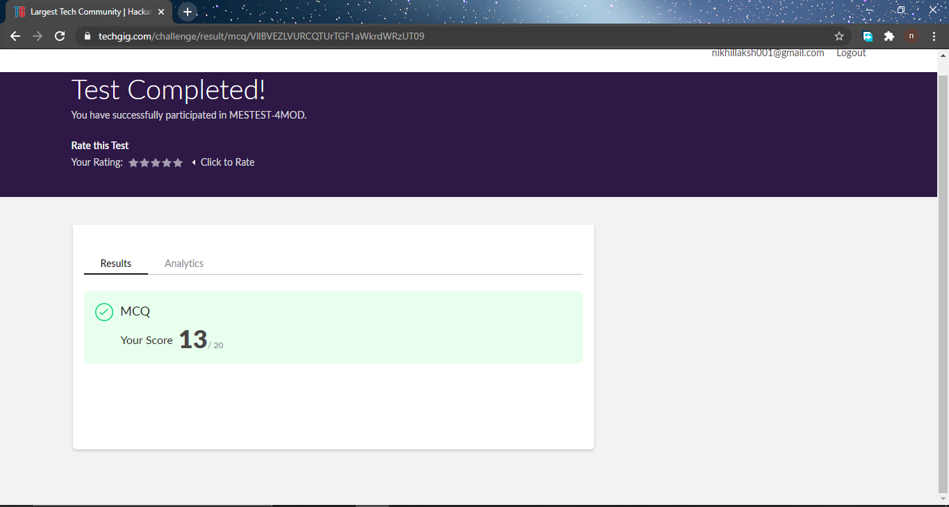

**Certification Course Summary: Today I have finished the certification course “Introduction to Ethical Hacking” and the snapshot of the certificate is given below:**

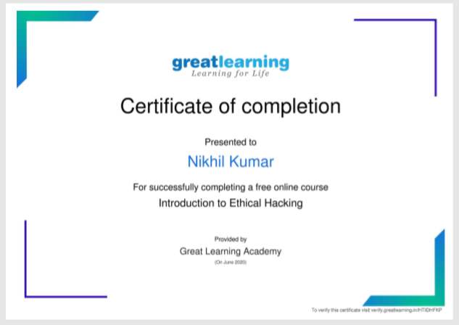

**Online Coding Summary: Today I received programs from prof . venkatesh and prof. shilpa CSE Dept. The program is mentioned above(pg.01). to my GitHub repository link and I’ve shared the snapshot below.**

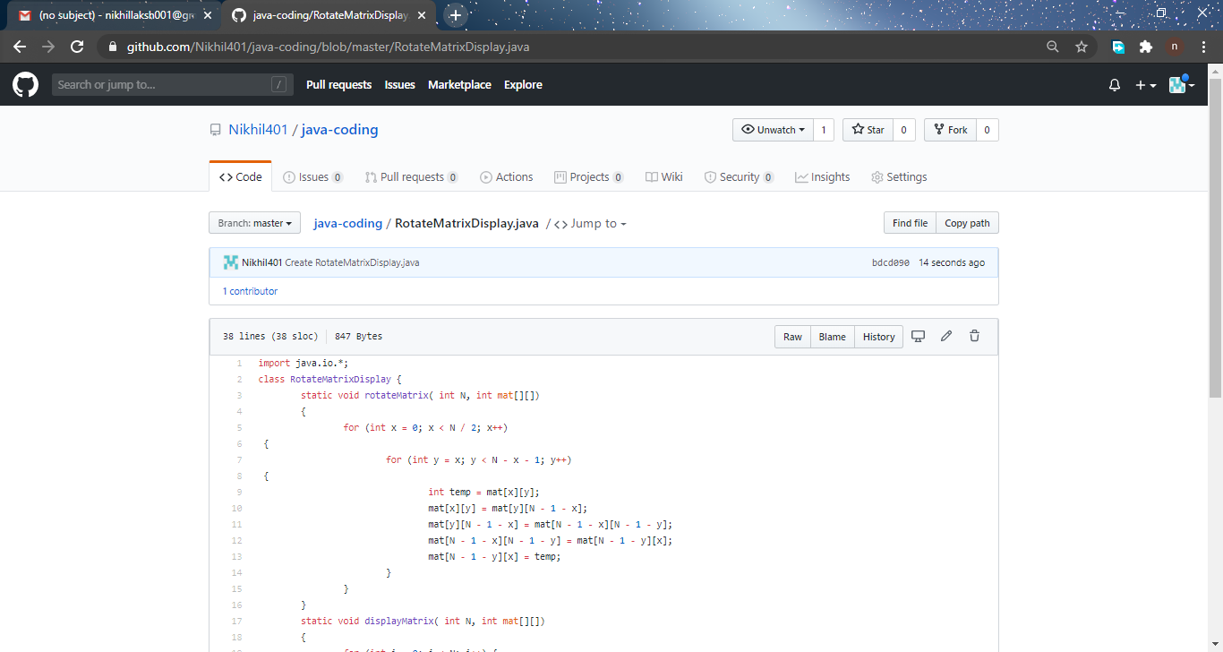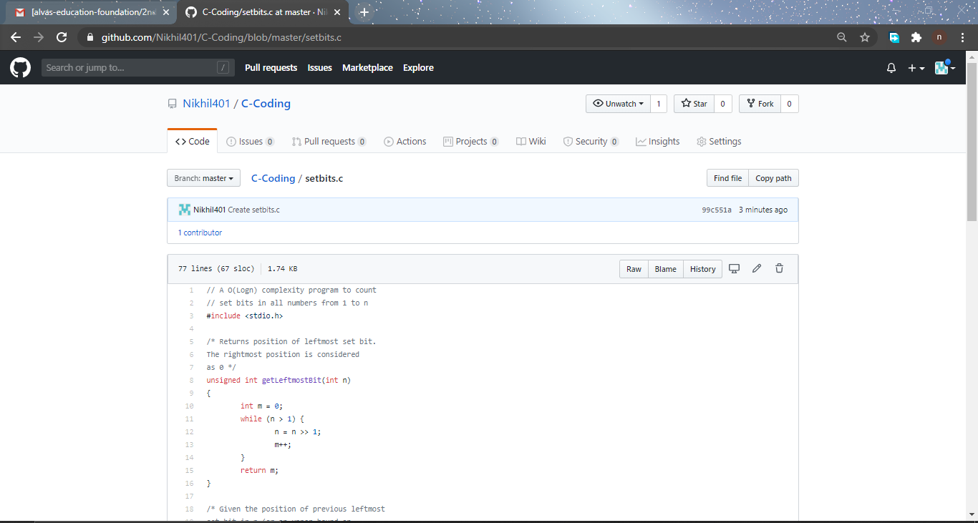 **Thank you.**